DIGITAL X-RAY REPORT
NAME: SURENDRA KUMAR AGE: 39Y/M
UHID : 97599 DATE: 12-12-2019
INTRAVENOUS UROGRAPHY :
Plain X-ray K.U.B. area: Radio-opaque opacity seen between the transverses
process of L2-L3 verrtebra on left side.
Both Psoas shadows normal.
Bones under view unremarkable.

IVP examination: Done with IV injection 50 ml of Contrapaque and films
taken at different intervals . Prone films were also taken.

Left kidney : is normal nephrogram and concentration of contrast
media .
Mild hydronephrosis with hydroureter seen upto the
calculus .

Right Kidney: is normally functioning and normal in shape, size,
position and regular in outline.
Pelvicalyceal system is normally outlined. No evidence
of hydronephrosis seen.
Right Ureter: Normally outlined with no evidence of hold up or
dilatation.
Urinary Bladder: Normal in shape, regular in outline.
Please correlate clinically.

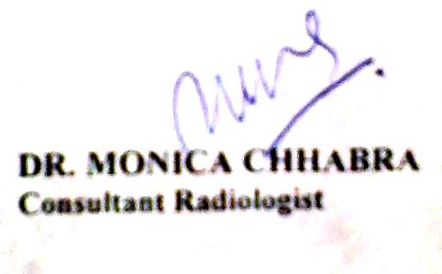

DIGITAL X-RAY REPORT
NAME : SURENDER KUMAR AGE/SEX : 39Y/M
DATE : 10/12/2019 UHID : 97599
X-RAY CHEST PA VIEW:
Both the lung fields show no active parenchymal pathology.
Both the costophrenic angles are clear.
Heart size is normal.
Both the domes of diaphragm are normal.
Bony thorax appears normal.
Suggested : Clinical correlation

DIGITAL X-RAY REPORT
NAME : SURENDER KUMAR AGE/SEX : 39Y/M
DATE : 06/12/2019 UHID : 97599
X-RAY KUB :POOR PREPARATION
Radio-opaque opacity seen overlying the transverse process of L3 vertebra on left side.
Bones under view are unremarkable.
Both psoas shadows appear normal.
Please correlate clinically with USG finding.

